Exercise 2

- Please write a HTML form as follows:
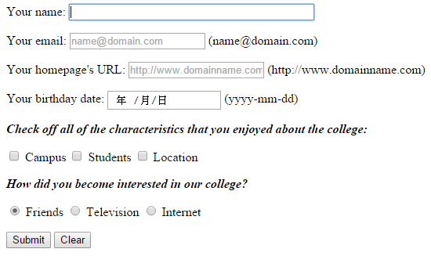
Requirements：
- 滑鼠指標需落在「Your name」的輸入欄位中。
- E-mail若不填寫，使用者按下submit後會出現強制輸入之訊息。
- 若E-mail填寫錯誤的格式或Homepage填寫不對的URL (例如少了http)，使用者按下submit後會出現提示訊息。
- Birthday可透過選取設定或直接輸入數字。
- 單選與複選選項請按照題目要求設計，而使用者不論點選該選項之文字或checked box/radio button之按鈕，都可以選取該選項。

Hints:
- Understand various types of HTML input elements.
- Use <label> to group the text and its <input> element.

- Add an embedded style sheet to the HTML document shown below:
- All text will use a Tahoma font. If Tahoma is not supported by the system, a sans-serif font is used.
- The style sheet should contain a rule that display h1 elements in blue.
- Create a rule that displays all links in blue without underlining them.
- When the mouse hovers over a link, change the link’s background color to yellow.
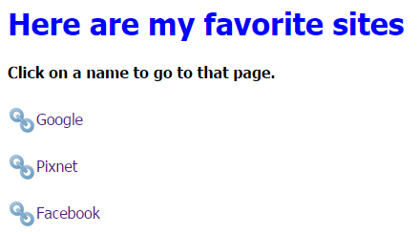

Note:
- Don't forget to set the " alt " attribute of <img> for the validation
- Please shrink the image to 30 x 30 (pixels)
- Please shift the image down 10 pixels to slightly adjust the layout

- Please let these two programs pass the validation of http://validator.w3.org/ and http://jigsaw.w3.org/css-validator/ and upload the screenshots of validation results.

